SAFETY DATA SHEET

- CHEMICAL PRODUCT AND COMPANY IDENTIFICATION

Product Name: ES 3902-S Validation Date: 5/11/15

Company Identification: Contact Information:
US Headquarters 1-800-255-3924 (For Emergencies – CHEMTEL)
APTech Group, Inc. 1-866-489-9831 (For product information)
11411 Williamson Road 1-513-761-6856 (Fax)
Cincinnati, Ohio 45241 USA info@aptechsolids.com (email)
- HAZARDS IDENTIFICATION

Classification of the substance or mixture
Acute toxicity, Oral (Category 4), H302
Eye damage/irritation (Category 2B), H319

PICTOGRAM/SYMBOL:
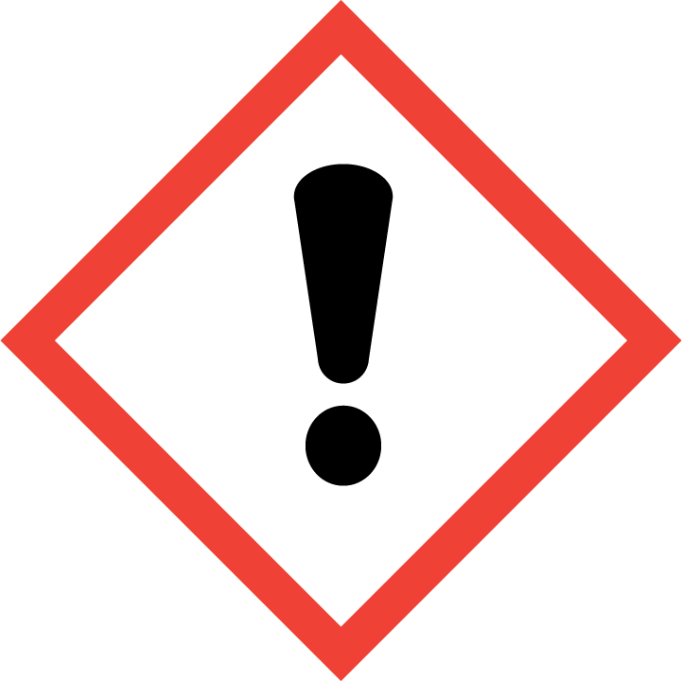

SIGNAL WORD: WARNING

HAZARD STATEMENTS - LABEL ELEMENTS
Health Hazards Statement(s)
H302 |  |  | Harmful if swallowed
H319 |  |  | Causes serious eye irritation
Physical Hazards Statement(s)
None
Precautionary Statement(s) - Prevention
P264 |  | Wash skin and contaminated clothing thoroughly after handling
P270 |  | Do not eat, drink or smoke when using this product
P280 |  | Wear protective gloves, protective clothing, eye protection, face protection
Precautionary Statement(s) - Response
P301+P312 |  | IF SWALLOWED: Call a POISON CENTER or doctor/physician if you feel unwell
P330 |  | Rinse mouth if ingested
P305+P351+P338+P310 |  | IF IN EYES: Rinse cautiously with water for several minutes. Remove contact lenses, if present and easy to do. Continue rinsing. Immediately call a POISON CENTER or doctor/physician
P337+P313 |  | If eye irritation persists: Get medical advice/attention
Precautionary Statement(s) - Storage
None
Precautionary Statement(s) - Disposal
P501 | Dispose of contents/container in accordance with applicable local, regional, national, and/or international regulations

- COMPOSITION / INFORMATION ON INGREDIENTS

INGREDIENT(S) | CAS Number | Weight %
Tolytriazole, Sodium Salt | 64665-57-2 | 5-10
Phosphonobutanetricarboxylic acid, sodium salt | 40372-66-5 | 1-5
Hydroxyethylidenediphosphonic acid, sodium salt | 29329-71-3 | 15-20
Polymaleic acid, sodium salt | 70247-90-4 | 10-15

>65% of mixture consists of ingredients of unknown toxicity. Exact percentages are withheld as trade secrets.

- FIRST AID MEASURES

EYE CONTACT: Immediately flush eyes with plenty of water, occasionally lifting the upper and lower eyelids. After 5 minutes, check for and remove any contact lenses. Continue to rinse for at least 15 minutes.
SKIN CONTACT: Wash with plenty of water. Remove contaminated clothing and shoes. Continue to rinse for at least 15 minutes. Wash clothing before reuse. Clean shoes thoroughly before reuse.
INHALATION: Remove from exposure and move to fresh air immediately and keep in position comfortable for breathing. If breathing is difficult, give oxygen. Do NOT use mouth-to-mouth resuscitation. If breathing has ceased apply artificial respiration using oxygen and a suitable mechanical device such as a bag and a mask.
INGESTION: Do NOT induce vomiting. If victim is conscious and alert, wash out mouth with water then give water. Never give anything by mouth to an unconscious person. If vomiting occurs spontaneously, keep airway clear.
NOTES TO PHYSICIAN: Treat symptomatically and supportively.
- FIRE FIGHTING MEASURES

NOTE: Solid product. Product will melt and combustion may occur when exposed to fire.
General information: As in any fire, wear a self-contained breathing apparatus in pressure-demand, MSHA/NIOSH (approved or equivalent), and full protective gear. During a fire, irritating and highly toxic gases may be generated by thermal decomposition or combustion. Use water spray to keep fire-exposed containers cool.
Extinguishing Media: Use any media suitable for the surrounding area. Use water spray to cool fire exposed containers. Do NOT use straight streams of water.
- ACCIDENTAL RELEASE MEASURES

IN CASE OF SPILL OR OTHER RELEASE: Remove sources of ignition. Ventilate area. Use appropriate personal protective equipment as indicated in Section 8 of the SDS when risk assessment indicates this is necessary. Use non-sparking tools and equipment. Sweep or shovel spilled materials into suitable containers. Dispose of in accordance with all local, state and federal requirements. Do not allow product or residues to enter waterway or any source of drinking water.
- HANDLING AND STORAGE

HANDLING: Use appropriate personal protective equipment (see Section 8). Eating, drinking and smoking should be prohibited in areas where this material is handled, stored and processed. Workers should wash hands and face before eating, drinking and smoking. Do not get in eyes or on skin or clothing. Do not breathe vapor or mist. Do not ingest. Use only with adequate ventilation. Keep in the original container. Store and use away from heat, sparks, open flame or any other ignition source. Do not reuse container.
STORAGE: Store in accordance with local regulations. Store in a segregated and approved area. Store in original container protected from direct sunlight in a dry, cool and well-ventilated area, away from incompatible materials (see Section 10) and food and drink. Separate from oxidizing materials and acids. Keep container tightly closed and sealed until ready for use.

- EXPOSURE CONTROLS / PERSONAL PROTECTION

ENGINEERING CONTROLS: Facilities storing or utilizing this material should be equipped with an eyewash facility and a safety shower (ANSI Z358.1). Use adequate general or local explosion-proof ventilation.
PERSONAL PROTECTIVE EQUIPMENT
Eyes: Wear chemical splash goggles that meet the requirements of 29 CFR 1910.133 or European Standard EN 166.
Skin: Wear appropriate protective gloves to prevent skin exposure (29 CFR 1910.138 or EN 374).
Clothing: Wear appropriate protective clothing to prevent skin exposure.
Respirators: A respiratory protection program that meets OSHA 29 CFR 1910.134 and ANSI Z88.2 requirements or European Standard EN 149 must be followed whenever workplace conditions warrant respirator use.

- PHYSICAL AND CHEMICAL PROPERTIES

FORM: | Solid
ODOR: | Characteristic
ODOR THRESHOLD: | No data available
COLOR: | Off-White
pH: | ~6.0-7.0 @ 1%
FREEZING POINT: | No data available
BOILING POINT: | No data available
FLASH POINT: | No data available
EVAPORATION RATE: | No data available
FLAMMABILITY: | No data available
FLAMMABILITY/EXPLOSIVE LIMIT: | No data available
AUTOIGNITION TEMPERATURE: | No data available
VAPOR PRESSURE: | No data available
VAPOR DENSITY: | No data available
DENSITY: | No data available
SOLUBILITY IN WATER: | Complete (slowly)
PARTITION COEFFICIENT N-OCTANOL/WATER: | No data available
AUTOIGNITION TEMPERATURE: | No data available
DECOMPOSTION TEMPERATURE: | No data available

10. STABILITY AND REACTIVITY

STABILITY: The product is stable.
INCOMPATIBILITY WITH VARIOUS SUBSTANCES: Reactive or incompatible with the following materials: oxidizing materials, acids, reducing materials.
HAZARDOUS POLYMERIZATION: Under normal conditions of storage and use, hazardous polymerization will not occur.
HAZARDOUS DECOMPOSITION PRODUCTS: Decomposition products may include the following materials: carbon monoxide, sodium oxide, nitrogen oxides.

11. TOXICOLOGICAL INFORMATION

TOXICITY: No data available for product.
CARCINOGENICITY
Product/Ingredient Name | ACGIH | IARC | NTP
- | - | - | -

12. ECOLOGICAL INFORMATION

ENVIRONMENTAL INFORMATION: No Data Available For Product.

13. DISPOSAL CONSIDERATIONS

Chemical waste generators must determine whether a discarded chemical is classified as a hazardous waste. U.S. EPA guidelines for the classifications are listed in 40CFR 261.3. Additionally, waste generators must consult state and local hazardous waste regulations to ensure complete and accurate classification.

14. TRANSPORTATION INFORMATION

U.S. Bill of Lading Description: Not D.O.T. Regulated

15. REGULATORY INFORMATION

INTERNATIONAL INVENTORIES
All components of this product are listed on the following inventories: U.S.A. (TSCA), Canada (DSL).

U.S. REGULATIONS
California Proposition 65: This product contains a chemical(s) known to the state of California to cause birth defects or other reproductive harm (Acrylamide).
STATE RIGHT TO KNOW (RTK)
INGREDIENT(S) | CAS# | MA | NJ | PA | MN | CA
- | - | - | - | - | - | -

CERCLA/SARA 302/304
INGREDIENT(S) | CAS# | Weight % | CERCLA/SARA RQ (lbs) | Section 302 TPQ (lbs)
- | - | - | - | -

SARA 311/312 Hazard Categories
Immediate: X
Delayed: -
Fire: -
Reactivity: -
Sudden Release of Pressure: -
SARA 313:
None
Clean Air Act:
Not regulated.
Clean Water Act:
Not regulated.

16. OTHER INFORMATION

Hazardous Material
Information System (U.S.A.) Health: 2 Flammability: 0 Reactivity: 0

National Fire Protection
Association (U.S.A.) Health: 2 Flammability: 0 Reactivity: 0

HMIS and NFPA use a numbering scale ranging from 0 to 4 to indicate the degree of hazard. A value of 0 means that the substance possesses essentially no hazard; a rating of 4 indicates high hazard.
Date of Creation: 02/02
Issue Number: 6.3
Date of Revision: 5/11/2015
Prepared By: Compliance Group
The information contained in this Safety Data Sheet is intended to comply with the requirements of 29CFR 1910.1200. This information is believed to be accurate and based on data available to the manufacturer at this time. It is intended to be used as a guide to the safe handling and use by properly trained individuals. It is the end users responsibility to determine the suitability of the information for their particular purposes. This information is provided without warranty.

